Native American Economic Development Ecosystem for Climate Investment
DATE: February 7, 2023
FROM: Krystal Langholz
Calvert Impact, Inc.
klangholz@calvertimpact.org

Section 1: Synopsis on Tribal Economic Development
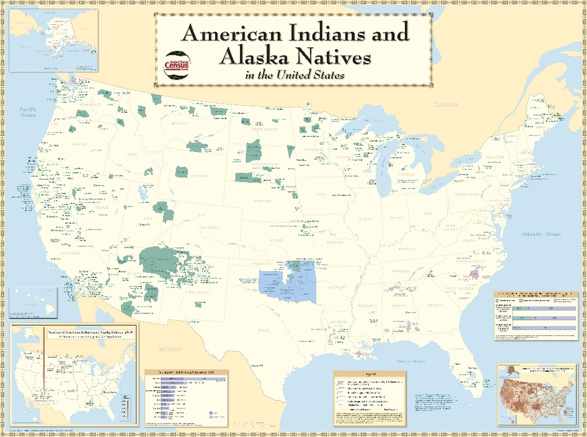
The are 574 federally recognized tribes and 63 tribes recognized by states in the United States. The US currently considers federally recognized tribes to be “domestic dependent nations” within the United States. Tribes hold to the right of self-government, a concept known as “tribal sovereignty”. Each tribe is unique with its own history, culture, governance, and environmental resources. There is great variation between tribes in size, wealth, and general cultural cohesion.
Land
There are 326 Indian reservations in the United States. Depending on the region, these might be called pueblos (New Mexico), rancherias (California), or reservations. Usually created by federal treaty, reservation lands—even on the same reservation—might hold many different land statuses (e.g. federal trust land, restricted fee land, etc.). Federal trust lands are managed by the Bureau of Indian Affairs (BIA), under the US Department of the Interior, unless the tribe has a contract with the BIA to manage their own lands. In addition to reservations, there are also Hawaiian Homelands, Oklahoma Tribal Statistical Areas, State Designated Tribal Statistical Areas and Alaskan Native Regional Corporations, all which have their own unique legal considerations surrounding land management and development.
Economic Development Infrastructure
Tribes are generally governed by a tribal government created and given authority by their constitutions. Most of these constitutions were created in 1934 by the Indian Reorganization Act, using a “boiler plate template” that originally called for the entire tribal government to be reelected every two years. While many of these constitutions have been amended, many tribes have kept these original constitutions. This means that the general stability of tribal governance can vary dramatically from tribe to tribe based on the strength of their constitution, as can legal economic development infrastructure like Uniform Commercial Codes.
In general, tribes often have economic development departments that oversee grant applications and economic development activities. These departments can vary in capacity, and they are often time housed underneath tribally owned economic development corporations, known commonly as “Section 17s”. These corporations draw their name from Section 17 of the Indian Reorganization Act, which gives tribes the power to create tribal corporations to engage in business transactions. Often many tribes will house all of their tribally owned businesses, known as “tribal enterprises” underneath these Section 17 organizations. A strong, well run tribally owned economic development corporation will generate income for the tribe and stability for tribal economic development activities. It is under these corporations that activities like solar projects, wind farms, and other sustainable economic development activities are most likely to be housed.
Section 2: General Recommendations for Partnership in Native Communities
- Connect: Engage with Native leaders to learn more about existing climate-solutions and to share opportunities at conferences, events, and through zoom conversations. In general, community leaders love to share their projects, ideas, and solutions.

- Build Partnerships: Due to structural barriers, transactions can take some time in Native communities to come to fruition. However, these efforts are high impact and transformative for communities that are often left out of the traditional capital markets due to these higher transaction cost. Long-term partnerships with tribal leadership and subject matter experts can flatten the learning curve and will ultimately lead to more scalable programmatic efforts.

- Support Native-led Efforts: While not all efforts must generate on the grassroots level, local engagement and capacity are key ingredients for the success of any projects in Native communities. It is important to understand to what degree identified solutions have buy-in at the local level in all transactions.

Section 3: Existing Climate Efforts
While there are very few universals among tribes regarding values, culture, or practice, responsible land stewardship—caring for the mother earth—is a serious priority for most tribal governments. Due to many tribal members’ high reliance still on traditional sustenance practices (e.g. fishing), higher poverty rates, and vulnerable locations, there is little doubt that tribal citizens will be disproportionately effected by climate change. Many tribes are both proactively and responsively confronting these challenges, such as the Tulalip Tribe and the Quinault Indian Nation.
Given that our mutual interdependence with the Earth is a core tenant of indigenous identify, tribal governments are generally receptive to, and at the forefront of, implementation of clean energy technologies. While there is little centralized infrastructure with which to track these trends, anecdotally, there are many tribes implementing solar, wind, and other renewable energies. A map of all tribal energy projects that have used funding from the US Department of Energy Office of Indian Energy can be found here.
Section 4: Existing Infrastructure in Native Communities
Due to a history of intentional disinvestment and destabilization of long-term social structures, much of the economic, resource management, and governmental infrastructure in Native communities is still in development. However, there were many Native organizations born out of the American Indian movement in the 70s, and this support infrastructure continues to mature. Today, there are many strong Native-focused and/or Native-led intermediaries that provide the connective tissue spread throughout Indian Country which could support your efforts.
There are 64 Certified Native Community Development Financial Institutions in the country and 20 Native owned banks. Native entrepreneurs, sometimes organized as small businesses (e.g. Solar Bear) and some as non-profits (e.g. Native Renewables), regularly receive capital through these intermediaries to scale their climate-focused efforts. While the size, scope and focus of these organizations vary considerably, but here are two that are important in the climate space:
- Native American Bank is owned by tribes across the United States. It provides many loans to the tribally owned enterprises, and it selectively participates in the US Department of Interior-Indian Energy and Economic Development guarantee program.

- NDN Fund is younger nation-wide loan fund owned by the NDN Collective, a large indigenous-led non-profit organization. Its focus is on lending to large-scale resilient and regenerative finance in Native communities.
In addition, there are other important intermediaries working in this space. Here are some other important ones:
- The National Center for American Indian Enterprise Development is a nonprofit organization which works on business and economic development for tribes. They host “Res” (the Reservation Economic Summit), held this year on April 3-6th in Las Vegas. This is the gathering where all tribal economic development organizations gather once a year, and there is usually a climate-focused track, where tribes will share about climate-focused solutions.

- National Congress of American Indians is the oldest representative governance organization serving tribal communities in the country.

- United Southern and Eastern Tribes (USET), Affiliated Tribes of Northwest Indians, and other regional governance organizations regularly bring together tribal leadership to share best practices, do regional advocacy, and administrate shared programs. Economic development support staff at these organizations will regularly coordinate regional economic development plans and know the finance needs of their member tribes. USET, for example, has a climate change “team” providing technical support to their membership.

Section 6: Potential People Resources

We are happy to make introductions to anyone we know in the space, as you continue your journey, but here are some recommended potential contacts:

Joel Smith, Chief Credit Officer, Native American Bank, jsmith@nabna.com
Kim Pate, NDN Fund Managing Director, Kim@ndncollective.org
Stewart Sarkozy-Banoczy, Resilient Cities Network and Precovery Labs (Consulting), banosaur@hotmail.com (Stewart has extensive working in climate-focused solutions and with Native American communities here in the US).
Rebecca Naragon, United Southern and Eastern Tribes, Economic Development Director, rnaragon@usetinc.org

